20

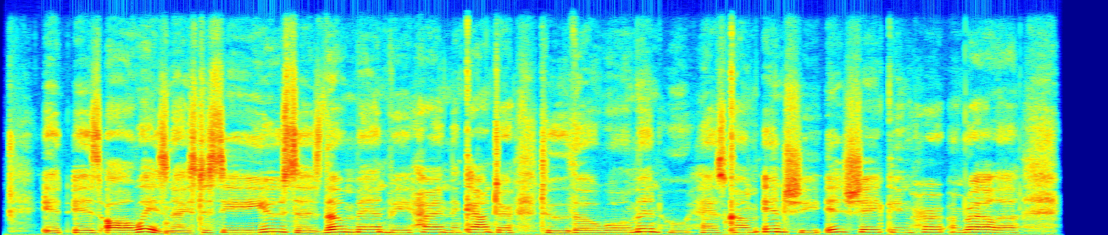

10

0

|  |  |  |  |  |  |  |  |  |  |
| --- | --- | --- | --- | --- | --- | --- | --- | --- | --- |
| 1 | 2 | 3 | 4 | 5 | 6 | 7 | 8 | 9 | 10 |
|  |  |  |  |  |  |  |  |  |  |
|  |  |  |  |  |  |  |  |  |  |
|  |  |  |  |  |  |  |  |  |  |
| 1 | 2 | 3 | 4 | 5 | 6 | 7 | 8 | 9 | 10 |

20

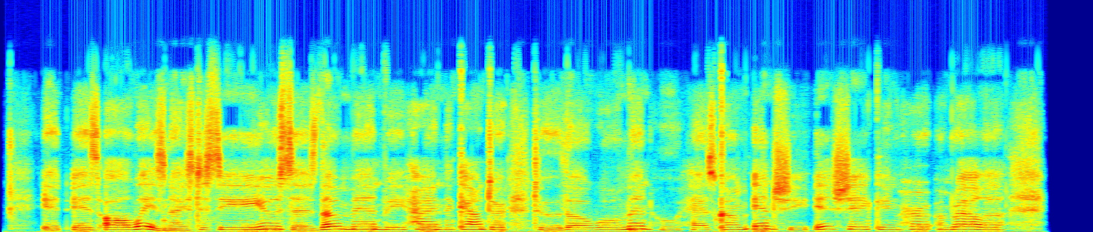

10

0

20

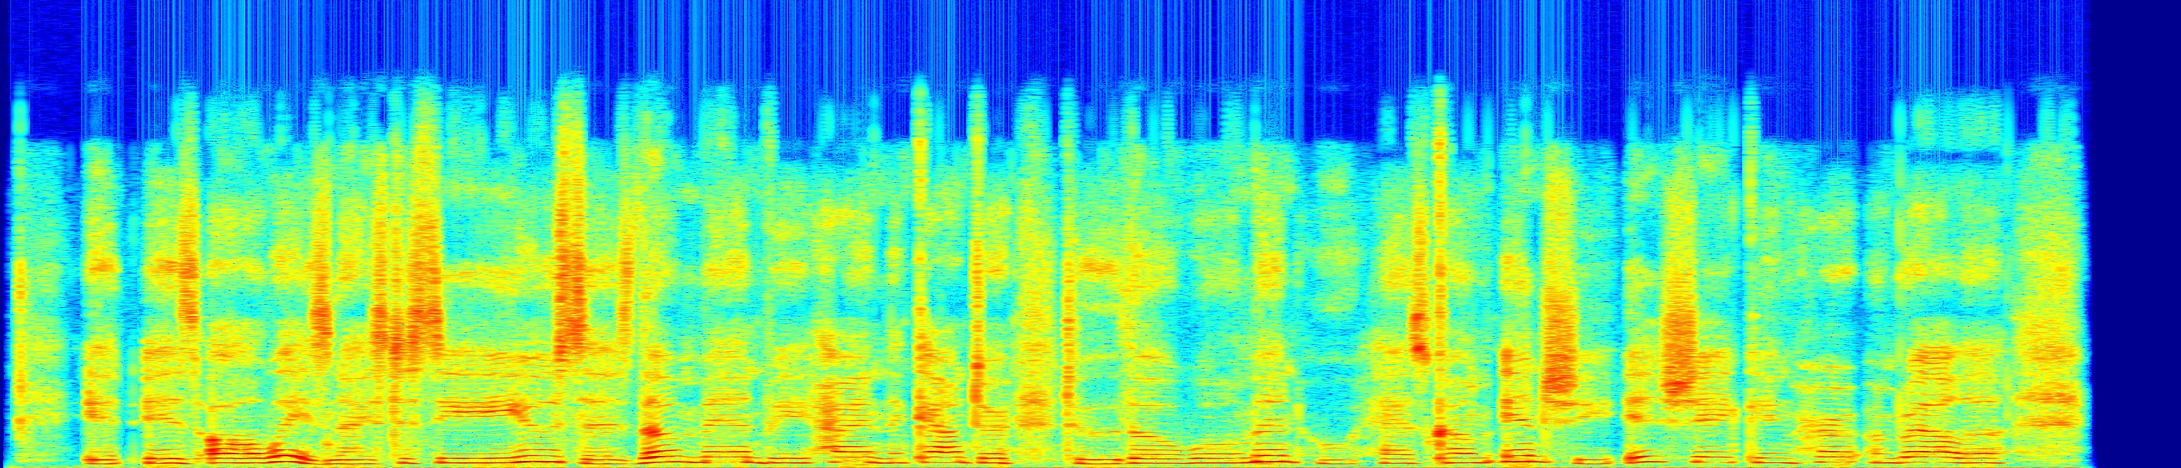

10

0

1 2 3 4 5 6 7 8 9 10

20

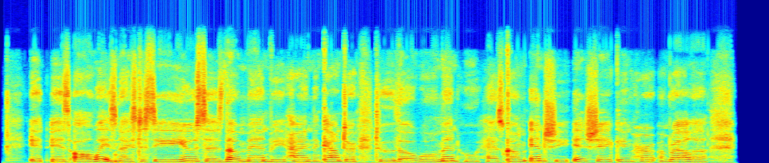

10

0

|  |  |  |  |  |  |  |  |  |  |
| --- | --- | --- | --- | --- | --- | --- | --- | --- | --- |
| 1 | 2 | 3 | 4 | 5 | 6 | 7 | 8 | 9 | 10 |
|  |  |  |  |  |  |  |  |  |  |
|  |  |  |  |  |  |  |  |  |  |
|  |  |  |  |  |  |  |  |  |  |
| 1 | 2 | 3 | 4 | 5 | 6 | 7 | 8 | 9 | 10 |

20

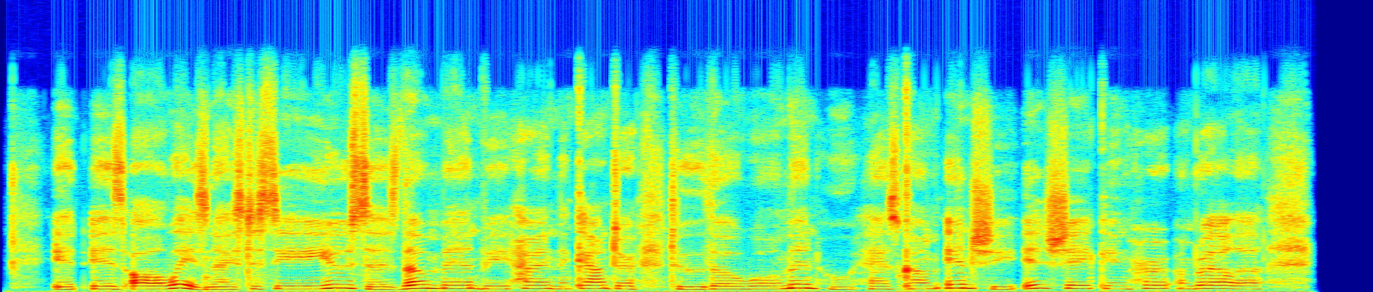

10

0